[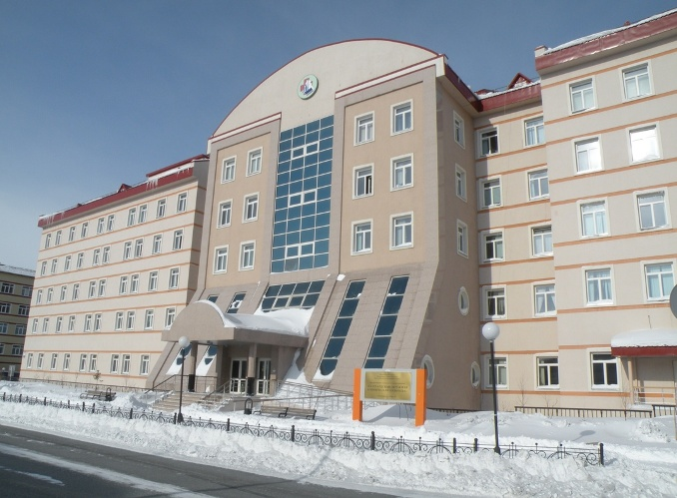](http://go.mail.ru/redir?q=%D1%81%D0%B0%D0%BB%D0%B5%D1%85%D0%B0%D1%80%D0%B4%D1%81%D0%BA%D0%B0%D1%8F%20%D0%B1%D0%BE%D0%BB%D1%8C%D0%BD%D0%B8%D1%86%D0%B0%20%D0%BA%D0%B0%D1%80%D1%82%D0%B8%D0%BD%D0%BA%D0%B8&via_page=1&sig=0082bb3b785c6280199b766786fabd8a&redir=http%3A%2F%2Ftoptyumen.ru%2F2016%2F02%2F25%2F14560)

**Салехардская окружная клиническая больница**

[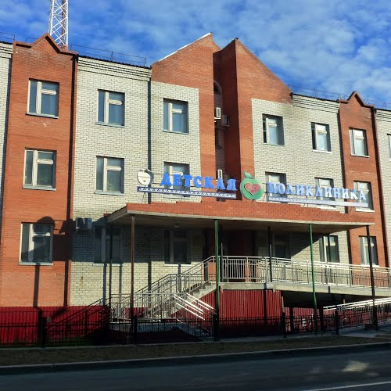](http://go.mail.ru/redir?q=%D1%81%D0%B0%D0%BB%D0%B5%D1%85%D0%B0%D1%80%D0%B4%D1%81%D0%BA%D0%B0%D1%8F%20%D0%B1%D0%BE%D0%BB%D1%8C%D0%BD%D0%B8%D1%86%D0%B0%20%D0%BA%D0%B0%D1%80%D1%82%D0%B8%D0%BD%D0%BA%D0%B8&via_page=1&sig=c3b3e24c87e277179ec4696b05044aff&redir=http%3A%2F%2Fwww.weatheravenue.com%2Fru%2Feurope%2Fru%2Fyamal-nenets%2Fsalekhard-fotografii.html)

**Детская поликлиника**